How to Complete BOM Details on NIFs
Created: 1/13/2023 Updated: 10/7/25
Which BOM Section Should I Complete?
- When to Complete the “BOM Setup”:
- Display, repack, or ECOMM/ECOMM VP SKUs produced by Menasha:
  - CA VAS BOM location: 1460
  - US VAS BOM locations: 1401, 1408, 1412, 1422, 1430, 1485
  - Pringles VAS BOM location: 1409
  - Frozen VAS BOM locations: 1724, 1727, 1728, 1751, 1772
- RX Display (produced by 12 Associates), repack, ECOMM/ECOMM VP, or VP SKUs produced at these locations:
  - RX VAS BOM location: 1408

- When to Complete the “0200 BOM”:
- The 0200 BOM is needed for the Data Sync process. It is used to communicate to customers, what is in the variety pack.
- Variety Pack SKU NOT produced at 1 of the locations above. If it’s produced at one of the locations above (ex: ECOMM VP SKU 19390800757), the “BOM Setup” Section should be completed instead.
  - Required if different UPCs on inner items. Not required if no UPCs on pouches.
  - Not required for CLUB
  - Not required for CA SKUs

- When to Complete the “DTC BOM”:
- DTC NIF
________________________________________________________________________________________________________________________________
How to Complete Each Section with Examples:
BOM Setup
Example: RX ECOMM VP produced at 1410 - 19390800757 RX AM 4 FLVS BARS 20CT 38.8OZX1 ECOMM
Important Notes:
- Can use WIP components for repacks and Club Packs (even if VAS). Please verify WIP components have UPCs/GTINs loaded and the following fields are maintained on the Classification tab: brand, business unit, country sold in, data sync, distribution method, first ship date, flavor, food form, manufacturing company, ordering lead time, ordering lead time UOM, package bar code type, package size, package size UOM, packaging profile, platform type, preliminary flag, sub-brand. If these attributes are not loaded for WIP components, the new material will error with Data Sync.
- Cannot use WIPs for displays as these components do not flow to TPM.
- The “Component Pkgs Per Case” and “Packages Per Mod Assortment” must have the same unit of measure. If using pouches for one, must enter pouches for the other.
  - Notice the “Number of Cases Required” count is the same in the 2 screenshots below, yet, they have different component quantities. This is because one is based off packages, while the other is based off pouches. Nonetheless, both give us what we need which is the total cases.
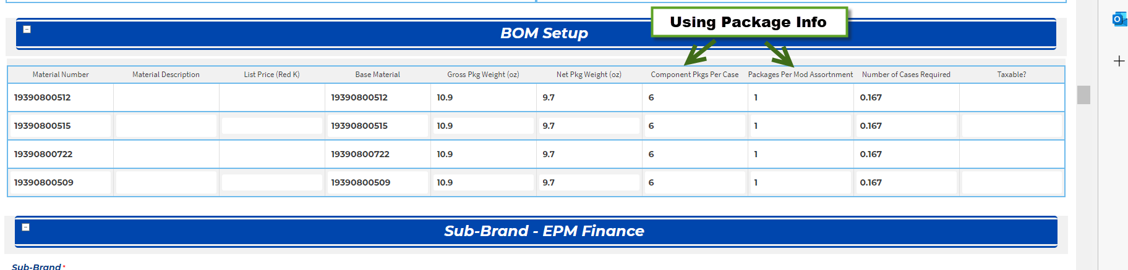
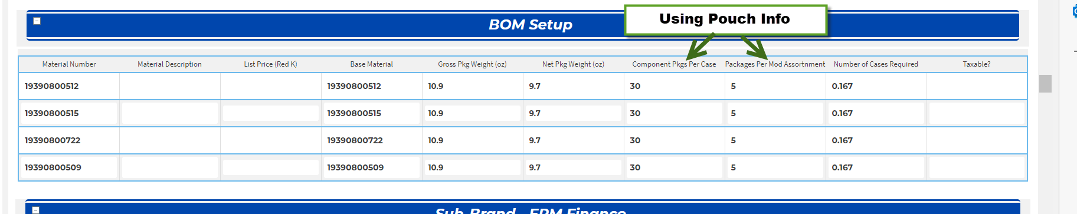

- The “Component Pkgs Per Case” refers to how many packages or pouches are in that specific component SKU.
- The “Packages Per Mod Assortment” refers to how many packages or pouches are needed for the SKU that we are setting up in the NIF.
- The “Number of Cases Required” field is auto-calculated (do not update value) and calculates each component’s case quantity needed for the total package or pouch count in the new SKU we are setting up.
- For Club SKUs produced at VAS, the “Number of Cases Required” field should reflect one Club Pack, not the full UL of the Club Pack (see 3800028677 as an example).
___________________________________________________________________________________________________________________________________
0200 BOM
Example: RX VP produced at 1601 - 19390800498 RX MINIS 2 FLVS BARS 8CT 7.36OZX6 VRTY
Important Notes:
- Typically, 0200 BOM is required only for variety packs with inner items that have different UPCs, but it should be completed as well if ECOMM with variety inner item UPCs and not set up at VAS.
- Never required for CA or Club SKUs
- Can use WIPs as components. Please verify WIP components have UPCs/GTINs loaded and the following fields are maintained on the Classification tab: brand, business unit, country sold in, data sync, distribution method, first ship date, flavor, food form, manufacturing company, ordering lead time, ordering lead time UOM, package bar code type, package size, package size UOM, packaging profile, platform type, preliminary flag, sub-brand. If these attributes are not loaded for WIP components, the new material will error with Data Sync.
- The “Calculation Check” for variety packs calculates the component’s case quantity needed for the total package or pouch count in just 1 VP case.
- Must use the lowest level when completing the columns below. Note, the units of measure do not need to remain consistent. For example, the 2nd column could reflect the component’s packages per case as that’s the lowest level and the 3rd column could reflect the pouches going into the VP.

Another VP Example in Depth - 3800016714 SPK 3 FLVS SNACK BAR 10.56OZX6
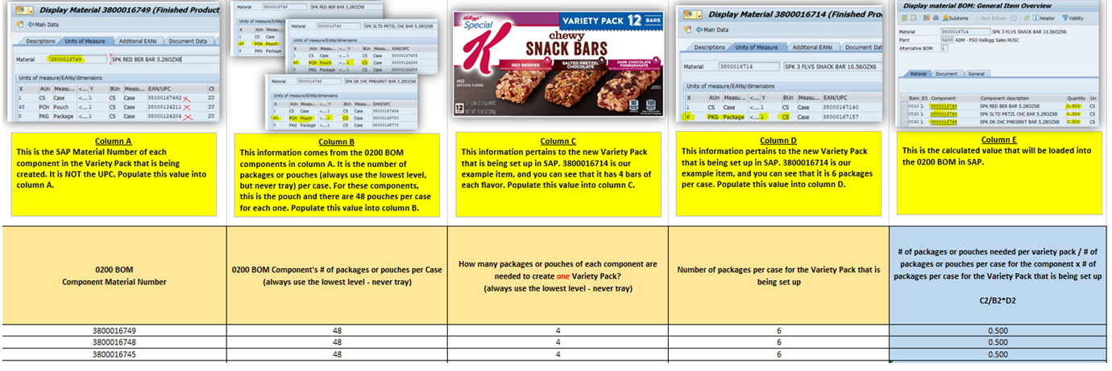___________________________________________________________________________________________________________________________________
DTC BOM
Example: 19390800742 RX MINIS BLBRY&STRW BARS 24CT 22OZX1 DTC
Important Notes:
- RX only: can use the RX Internal Coman WIP components in BOM (as seen below) if there is no retail case. The unit of measure will be “EA”.
- Unlike VAS and 0200 BOMs which have quantities that are typically not whole numbers (calculated values), DTC BOMs use actual bar/food item quantities. The unit of measure will be lowest level - “PCH” or “PKG”.
- Variety Pack DTC BOMs use the VP components, not the actual VP itself (as seen below).
- Should have retail components provided, no DTC SKUs allowed as components.
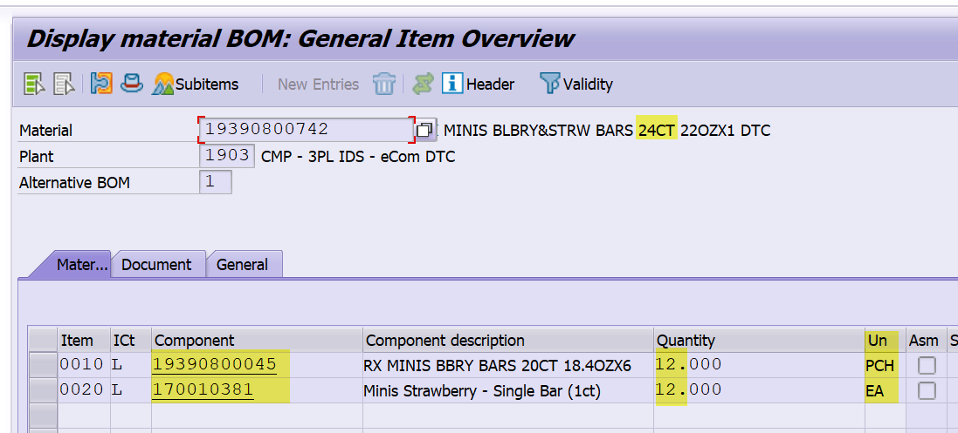
DTC Simple Bundle = Retail SKU at the package level (vs case level), or as a 1 count, for sale on Magento to be sold direct to consumer or business to business (B2B). The existing package UPC on the retail SKU is used for the DTC SKU and the DTC SKU gets a unique case code. This setup is used when selling the retail package DTC or B2B. The UOM will show 1 PKG=1CS and the BOM will have the food count of the retail component. For example, if the retail package has 12 bars inside, then DTC BOM will have 12 pouches (PCH) for the quantity. This setup is essentially making the retail package available DTC and/or B2B. B2B uses the DTC setup types because they both use the Magento platform for their websites.
DTC Static Bundle = Selling multiple flavors from retail SKUs OR selling multiple packages of an existing retail SKU to be sold direct to consumer or business to business (B2B). The DTC SKU will have the same case and package UPC. The UOM will also show 1 PKG = 1 CS and the BOM will have different flavors/and or 1 flavor with multiple counts. The BOM quantity for each component refers to the actual food/item count as seen in the screenshot above. The unit of measure will be lowest level - “PCH” or “PKG”.

